**TOOLS FOR CARPENTRY AND JOINERY**

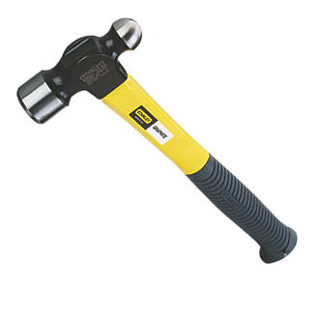**BALL PEIN HAMMER**

A ball-peen hammer, also known as a machinist's hammer, is a type of peening hammer used in metalworking. It has two heads, one flat and the other, called the peen, rounded. It is distinguished from a cross-peen hammer, diagonal-peen hammer, point-peen hammer, or chisel-peen hammer by having a hemispherical peen.

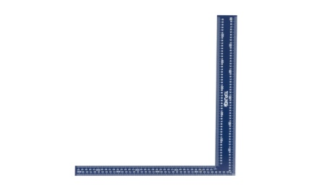**BUILDERS SQUARE**

The Builders Square is used where walls meet, calculating rafter angles, creating stairways, calculating octagons, and can be used as a diagonal square.

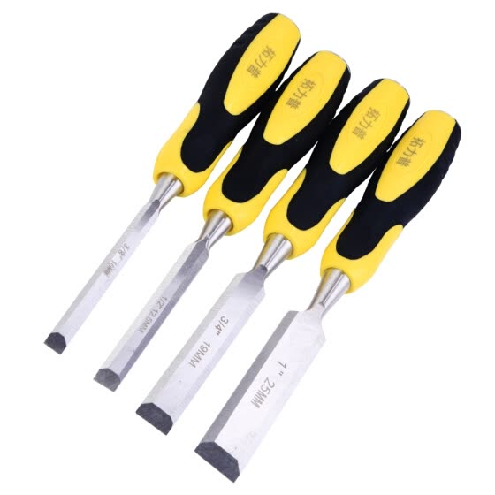**CHISEL**

A chisel is a tool with a characteristically shaped cutting edge of blade on its end, for carving or cutting a hard material such as wood, stone, or metal by hand, struck with a mallet, or mechanical power. The handle and blade of some types of chisel are made of metal or of wood with a sharp edge in it

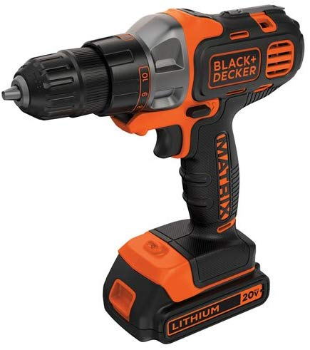**CORDLESS DRILL**

A cordless drill is an electric drill which uses rechargeable batteries. These drills are available with similar features to an AC mains-powered drill. ... They are available in the hammer drill configuration and most have a clutch, which aids in driving screws into various substrates while not damaging them.

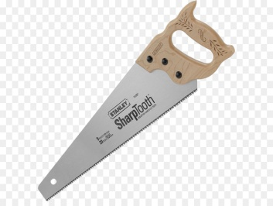**HAND SAW**

In woodworking and carpentry, hand saws, also known as "panel saws", are used to cut pieces of wood into different shapes. This is usually done in order to join the pieces together and carve a wooden object.

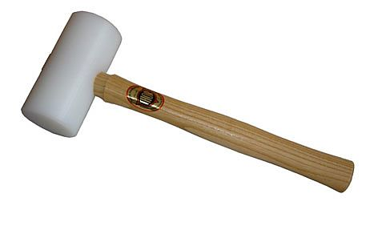**MALLET**

A mallet is a kind of hammer, often made of rubber or sometimes wood, that is smaller than a maul or beetle, and usually has a relatively large head

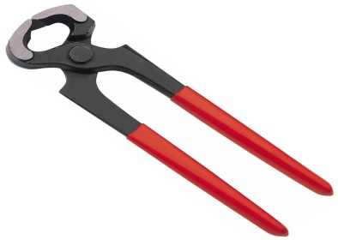**PINCER**

Pincers are a hand tool used in many situations where a mechanical advantage is required to pinch, cut or pull an object. Pincers are first-class levers, but differ from pliers in that the concentration of force is either to a point, or to an edge perpendicular to the length of the tool.

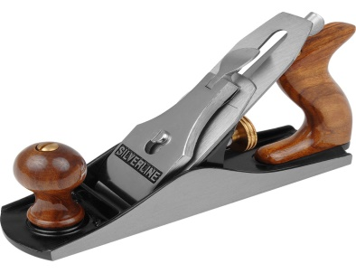**PLANERS (JACK PLANE)**

A jack plane (or fore plane) is a general-purpose woodworking bench plane, used for dressing timber down to the correct size in preparation for truing and/or edge jointing. ... In preparing stock, the jack plane is used after the scrub plane and before the jointer plane and smoothing plane.

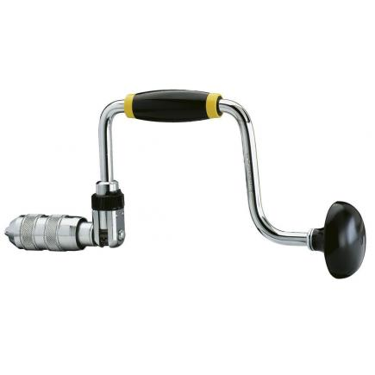**RATCHET BRACE**

Safety boots are shoes made with a protective reinforcement at the front making them quite durable. The reinforcement helps to protect the toes from falling objects or any kind of compression. They are normally installed with a sole plate in the main sole to prevent against punctures that may come from below.

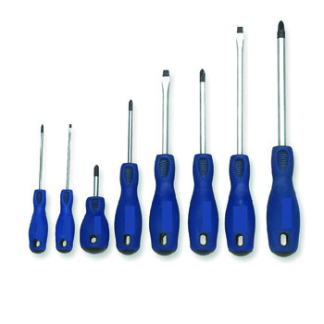**SCREW DRIVER**

A screwdriver is a tool, manual or powered, for screwing and unscrewing screws. A typical simple screwdriver has a handle and a shaft, ending in a tip the user puts into the screw head before turning the handle. The shaft is usually made of tough steel to resist bending or twisting.

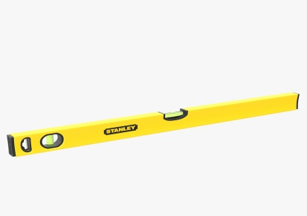**SPIRIT LEVEL**

A spirit level, bubble level or simply a level is an instrument designed to indicate whether a surface is horizontal or vertical.

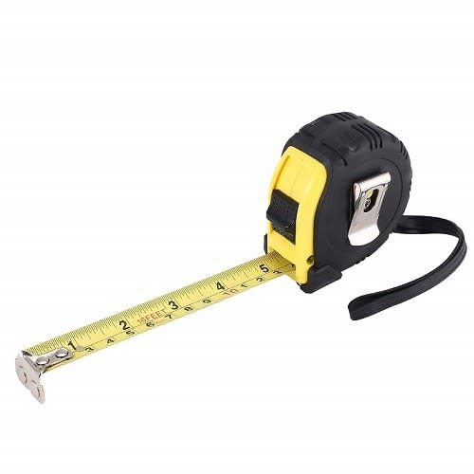**TAPE MEASURE**

A tape measure or measuring tape is a flexible ruler used to measure distance. It consists of a ribbon of cloth, plastic, fibre glass, or metal strip with linear-measurement markings. It is a common measuring tool.

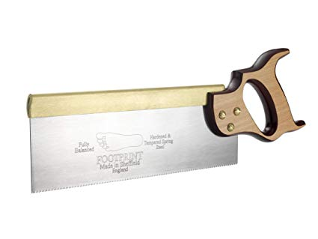**TENON SAW**

A tenonsaw is a kind of Backsaw that is used to cut straight lines in wood, it does not cut metal. It is used for cuts that do not go deep into the wood.

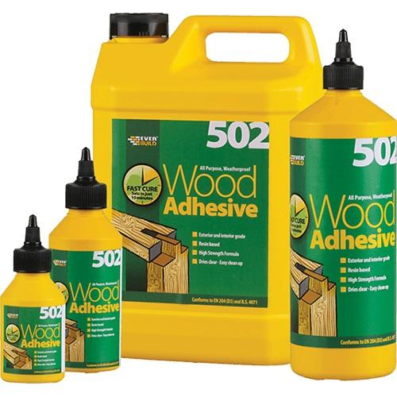**WOOD ADHESIVE**

Woodadhesives as a term can encompass many products for a variety of applications, but essentially these products are polymers designed for the joining of timber elements through application to the timber surfaces and binding them through either a chemical reaction or physical interlocking.

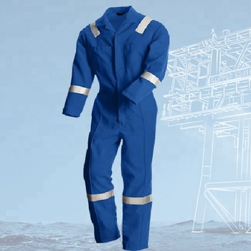**COVERALL**

A one-piece protective garment worn for heavy manual work; a boiler suit.

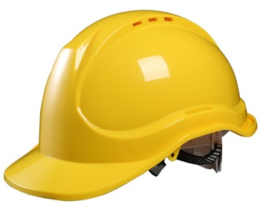**HELMENT**

A hardhat is a type of helmet predominantly used in workplace environments such as industrial or construction sites to protect the head from injury due to falling objects, impact with other objects, debris, rain, and electric shock. ... Some helmet shells have a mid-line reinforcement ridge to improve impact resistance.

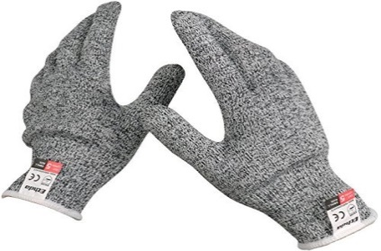**HANDGLOVE**

A glove is a garment covering the whole hand. Gloves usually have separate sheaths or openings for each finger and the thumb. If there is an opening but no (or a short) covering sheath for each finger they are called fingerless gloves.

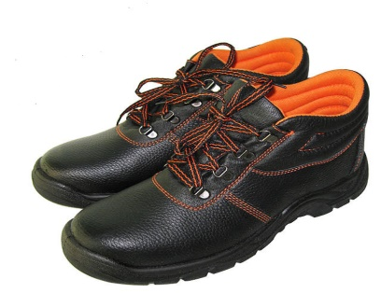**SAFETY WORK SHEOS (LEATHER)**

Safety boots are shoes made with a protective reinforcement at the front making them quite durable. The reinforcement helps to protect the toes from falling objects or any kind of compression. They are normally installed with a sole plate in the main sole to prevent against punctures that may come from below.